Jackson Warren

Jeremy Bergen

CSCI 370

10/29

Week 9 Lab: Chapter 8

Section 1:

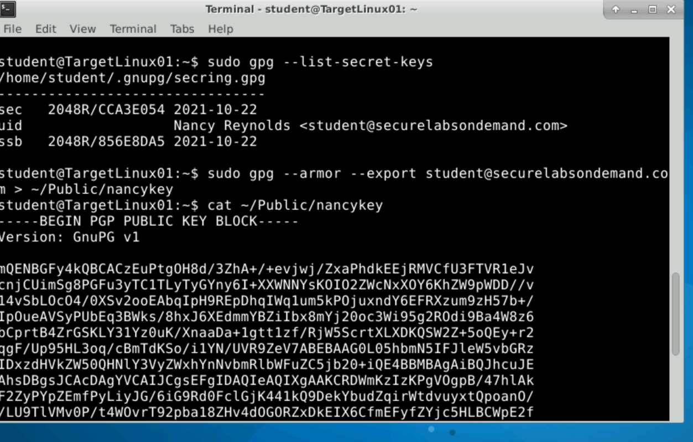

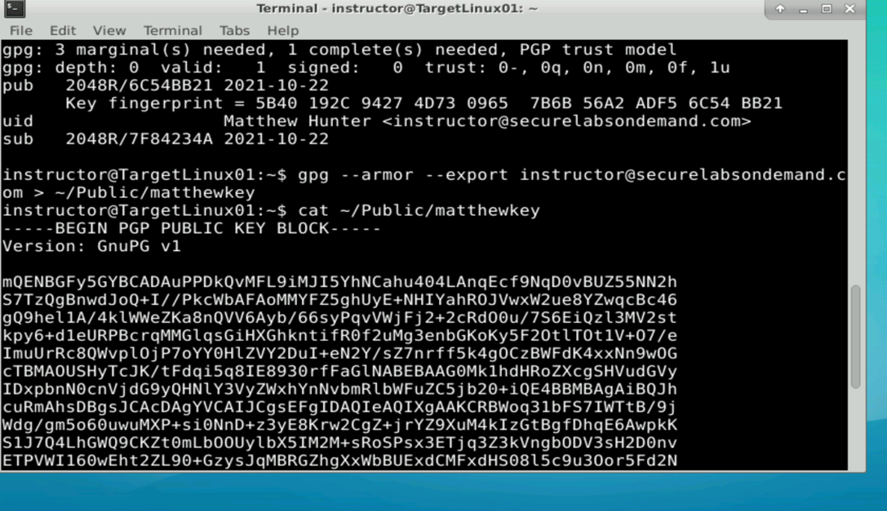

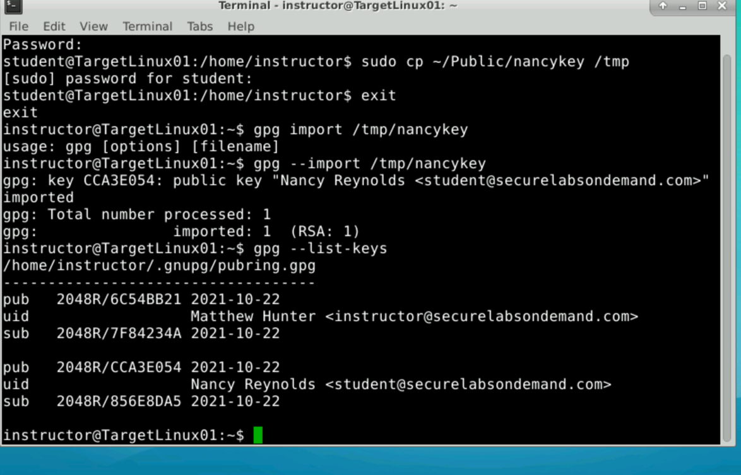

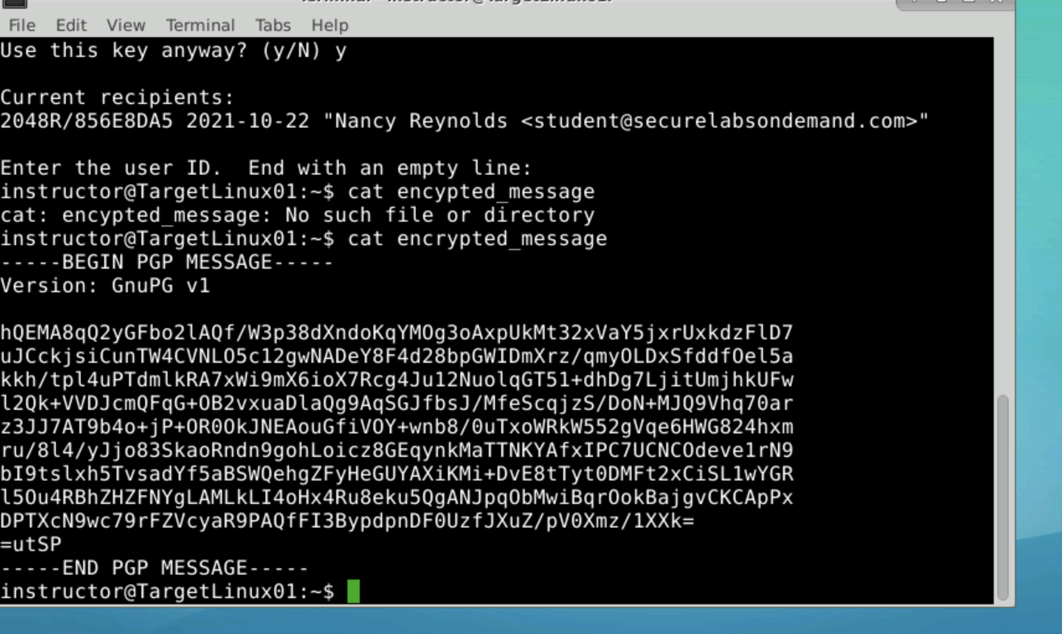

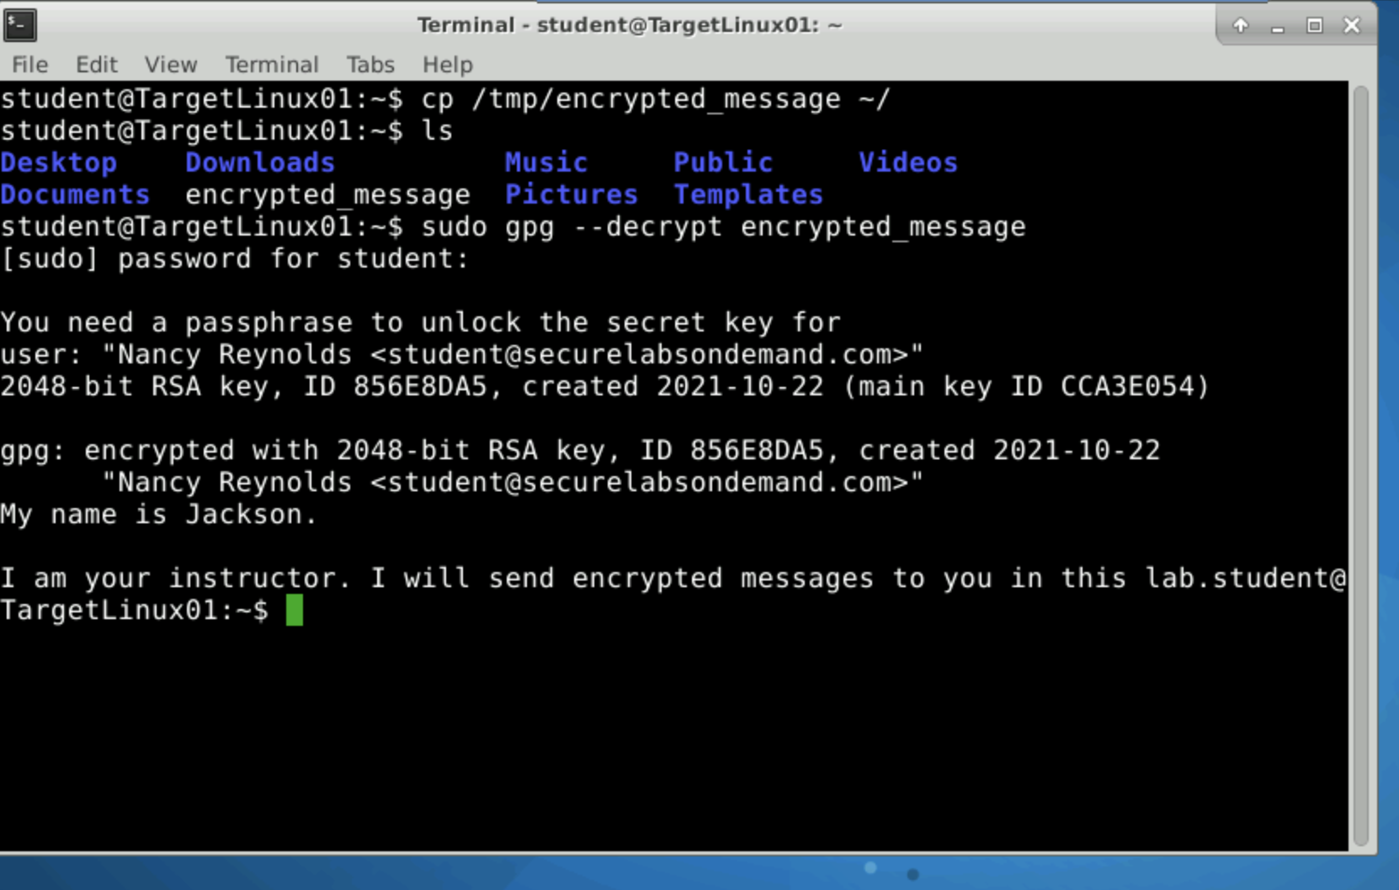

Section 2:

Password I used for encryption: I aint telling you my passwords. That aint secure!

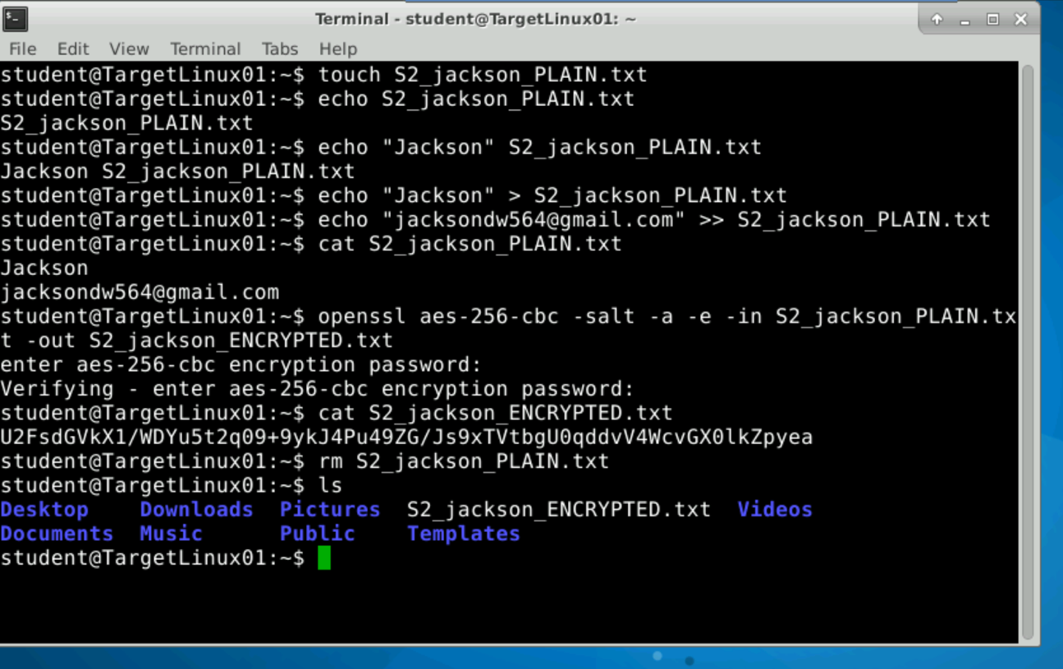

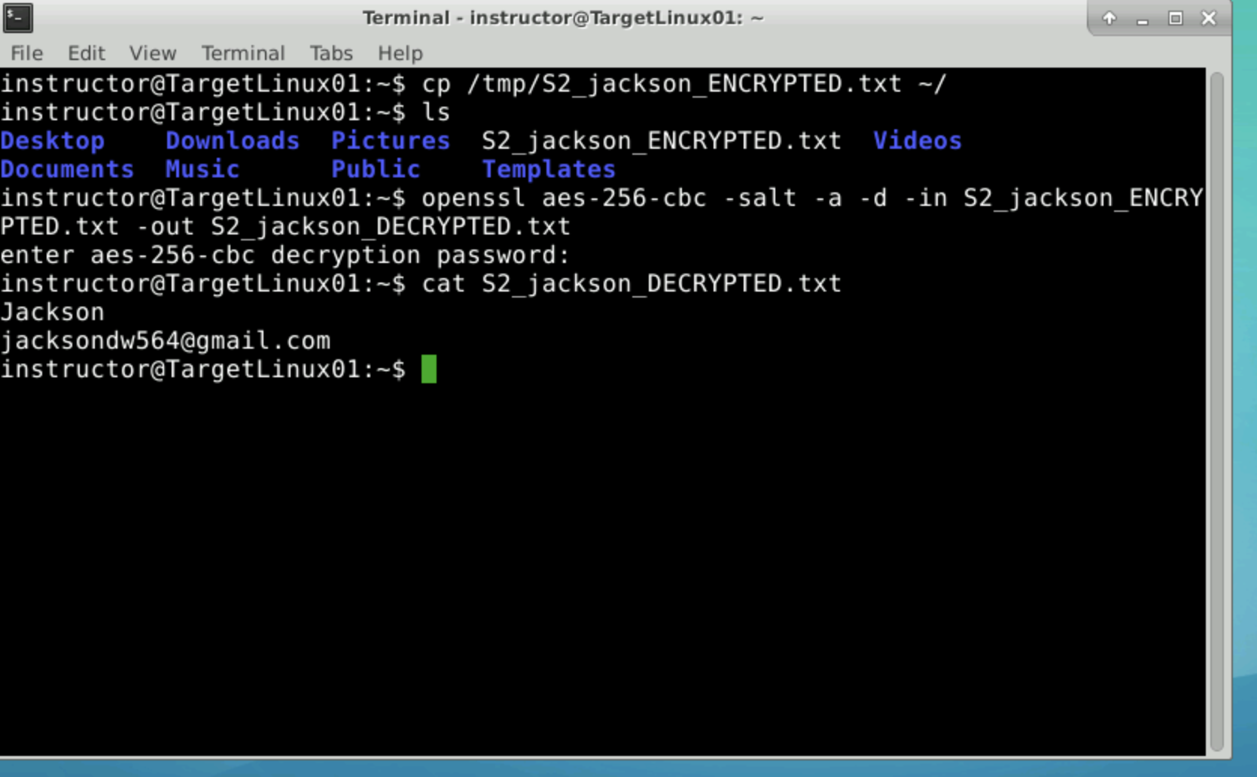

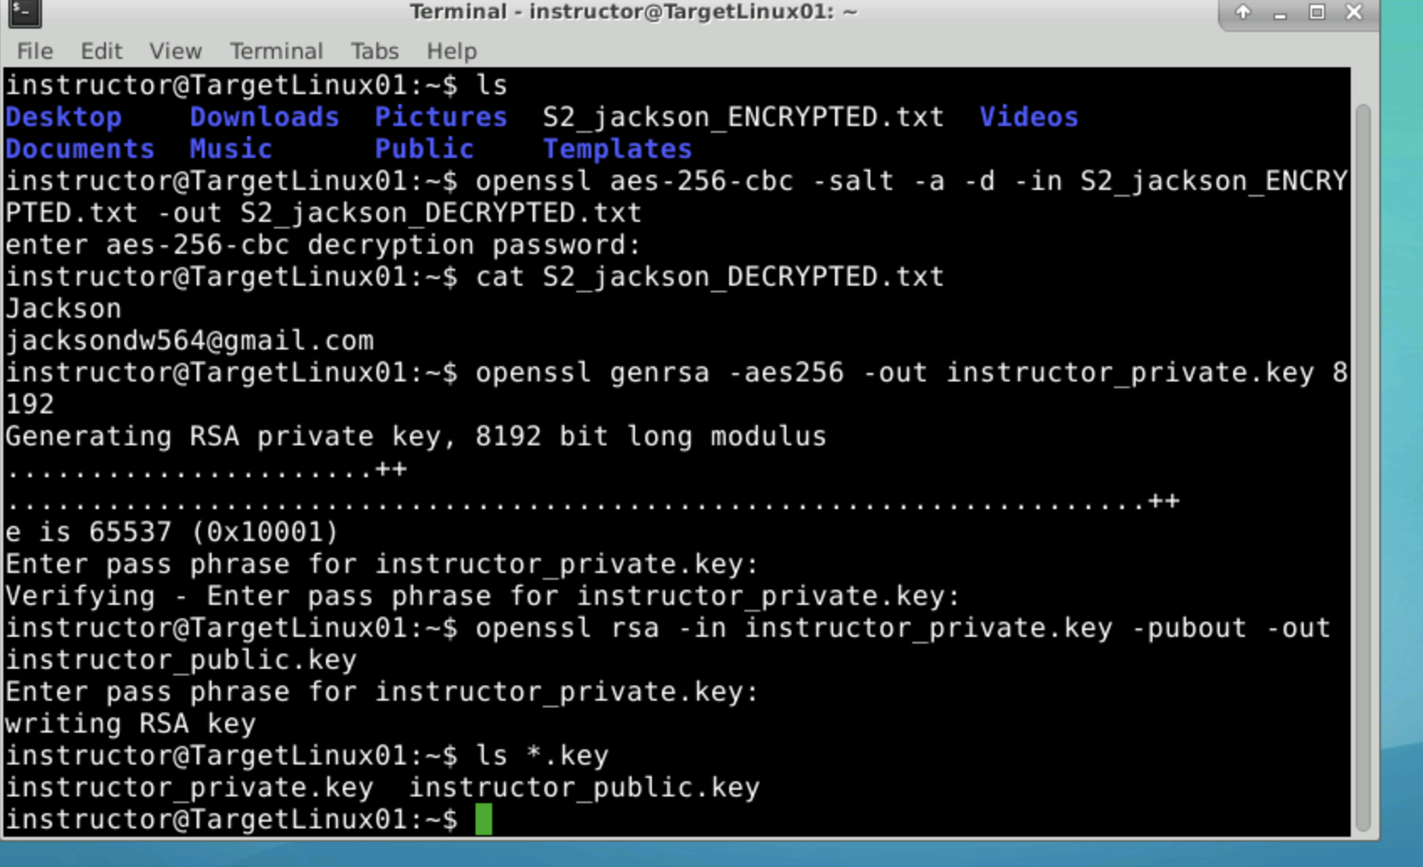

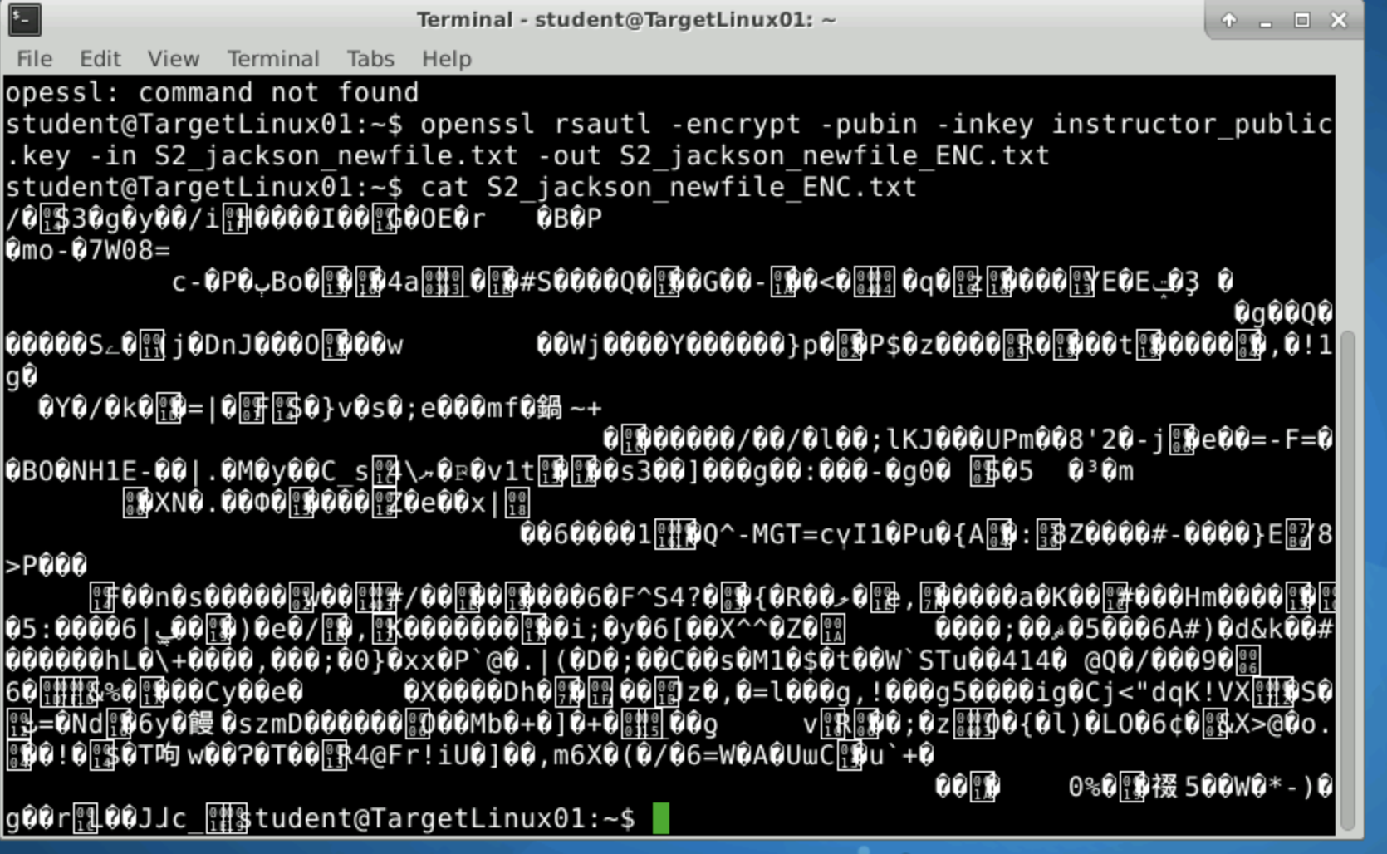

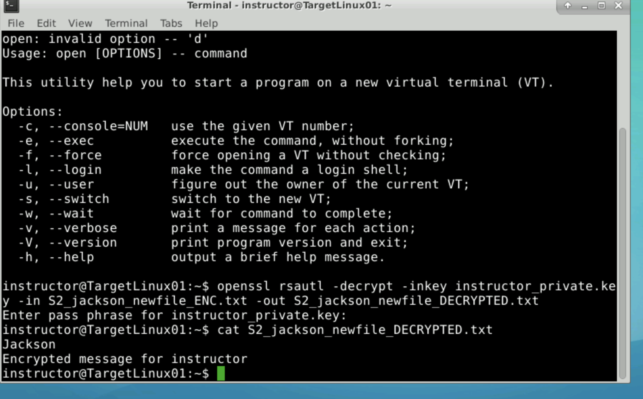

Section 3:

Part 1: If Nancy shares her private key, it defeats the entire point of the encryptions and security in the first place. It’s like giving someone your password. It renders the protections pointless. Not to mention, her own key is now being used and known by someone else.

Part 2: These Rainbow Tables are used for caching cryptographic hash functions. Its purpose is usually utilized for cracking passwords hashes. Salting renders these tables useless by randomizing these hashes, making each hash have specific random data added. Then, these tables are rendered useless and cannot track such hashes due to these random hash additions.

Part 3: 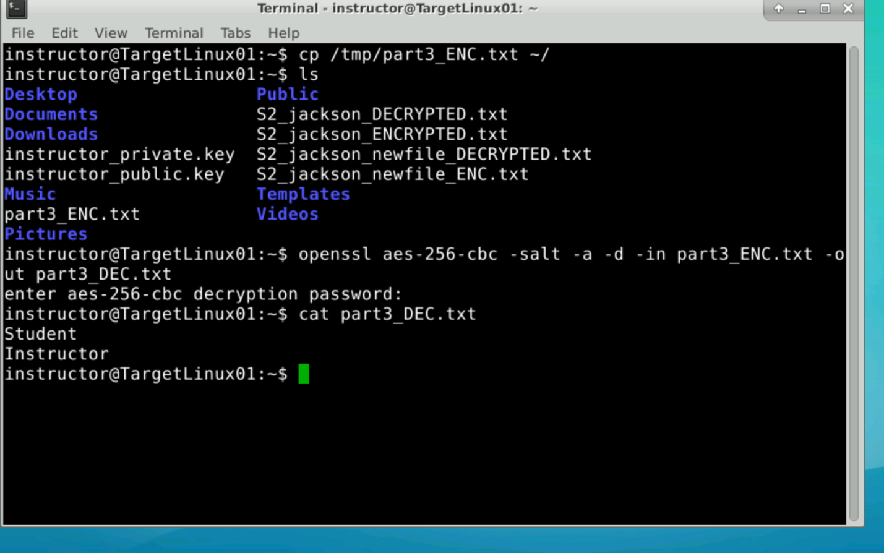

Forgot to include the school part for this. But we have the decrypted file with instructor and student in our Instructor’s account.